***RPM Motorcycle Shop Management System – Software Requirements Document***

**TEAM G5:**

Hadeer Amr 22010450

Hana Emad 2206184

Ahmed Yasser 2206158

Mohamed salah 22010448

This document outlines the requirements for the Motorcycle Shop Management System, designed to streamline sales and maintenance operations. It includes the business needs, functional and non-functional requirements, and user stories reflecting the needs of different user roles. Our goal is to enhance operational efficiency, ensure data accuracy, and provide a user-friendly and secure system with Arabic language support compatible with the local working environment. The client was contacted via voice call and email to gather and confirm these requirements.

***1. Business Requirements***

**1.1 Sales & Operations Management**

* Efficiently manage motorcycle sales and maintenance operations.
* Provide seamless customer management including purchase and service history.
* Support printing of invoices and maintenance reports.

**1.2 Inventory & Product Control**

* Maintain accurate and up-to-date inventory of motorcycles and spare parts.
* Ensure automatic updates of motorcycle status after sales and maintenance.

**1.3 User Access & Usability**

* Enable role-based system access for admins and technicians.
* Ensure system usability for non-technical staff with Arabic language support.

**1.4 Reporting & Performance Monitoring**

* Generate detailed reports for sales, maintenance, profits, and technician performance.

**1.5 Scalability & Deployment**

* Support future scalability for multiple branches.
* Deploy locally on the shop’s computer with possible future web version.

**1.6 Security & Reliability**

* Ensure data security, backup, and system reliability.

***2. Functional Requirement***

**2.1 Product Management**

• Add, edit, or delete motorcycle entries (model, brand, price, color, condition).

• View all motorcycles available for sale.

• Filter motorcycles by brand, type, or price range.

**2.2 Sales Management**

• Record motorcycle sales transactions.

• Link sales to customer details (name, phone, national ID).

• Generate and print invoices (PDF or screen preview).

• Automatically update motorcycle status to “sold” upon purchase.

**2.3 Maintenance Service Management**

• Register new maintenance requests including issue details and customer info.

• Schedule maintenance with date/time and assign technicians.

• Update maintenance status (In Progress, Completed, Not Completed).

• Log spare parts used and associated service costs.

**2.4 Customer Management**

• Record customer information.

• Display customer purchase and service history.

**2.5 User Management**

• System login for admins and technicians.

• Role-based permissions (admin vs technician).

• Admins can manage system users (add/edit/delete).

**2.6 Inventory Management**

• Monitor and update spare parts inventory.

• Auto-update stock levels after usage in maintenance.

• Receive alerts for low-stock spare parts.

**2.7 Reporting**

• Generate reports for:

1. Daily, weekly, monthly sales.
2. Number of maintenance tasks.
3. Overall profits.
4. Technician performance metrics

**3. Non-Functional Requirements**

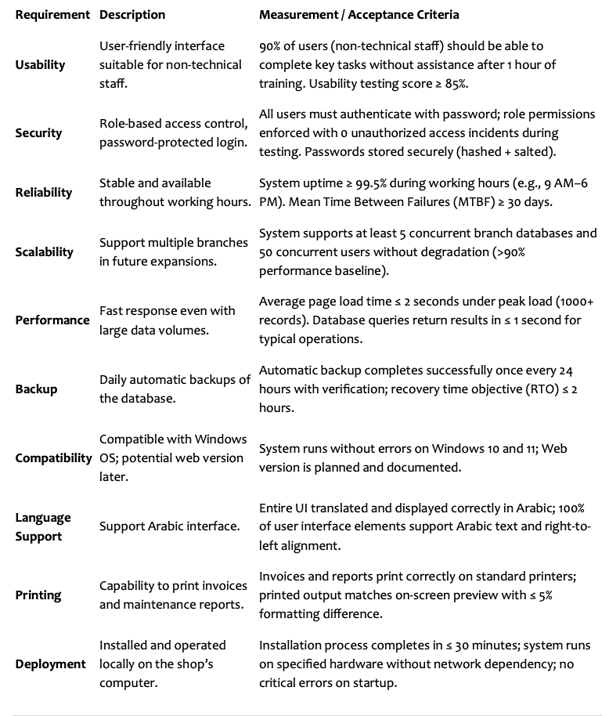

**4. User Stories**

The following user stories capture the specific needs and interactions of different user roles within the Motorcycle Shop Management System. They translate the business and functional requirements into practical scenarios, helping the development team understand how each type of user—administrators,

technicians, and customers—will use the system. This ensures the final product meets real-world workflows and improves user satisfaction.

**4.1 Administrator User Stories**

1. Add, edit, delete motorcycles to manage inventory.

2. Record sales linked to customer profiles.

3. Generate and print sales invoices.

4. Register and monitor maintenance tasks.

5. Manage user accounts and permissions.

6. Monitor spare parts inventory with low-stock alerts.

7. Generate sales, maintenance, and profit reports.

**4.2 Technician User Stories**

1. View assigned maintenance tasks.

2. Update task status and progress.

3. Add repair notes for documentation.

4. Track spare parts used in each repair.

**4.3 Customer User Stories (via staff)**

1. Receive printed invoice after purchase.

2. Be notified when maintenance is complete.

3. Access full history of past services and purchases for easier future interactions.

**Development Approach**

Based on the requirements we provided for RPM Motorcycle Shop Management System — and the fact that we already have a clear set of functional and non-functional requirements from the client but may still need flexibility for changes — we’d recommend Agile or Incremental over Waterfall.

**1. Agile Model**

**Why it fits:**

• We already have a detailed list of requirements, but as we start development, the client may request changes or new features (common in business systems).

• Agile allows delivering the system in small, usable parts (e.g., first release with Sales + Product Management, second release with Maintenance + Inventory).

• Continuous feedback from the shop owner/staff ensures the system matches actual daily operations.

• Good for user interface tuning (Arabic support, usability for non-technical staff).

**Pros for our case:**

• Client sees progress early.

• Bugs are found and fixed quickly.

• Priorities can shift without throwing away all work.

**2. Incremental Model**

**Why it fits:**

• Requirements are mostly known and stable.

• We can deliver the system in phases (increments), each fully functional for the features it covers.

• Lower risk than Waterfall since we can test and deliver parts before the whole system is done.

**Difference from Agile:**

• Incremental has fixed phases and less change mid-phase, while Agile embraces changes at anytime.

**Models We would not recommend here:**

**• Waterfall:**

Only works well if requirements are 100% fixed and unlikely to change — but business owners often change small things once they see the product.

**• Spiral:**

Best for high-risk, research-heavy projects; our system is fairly straightforward.

• **Iterative:**

Useful for redesign/refinement of a single concept, but we have many different modules —incremental delivery is more natural.

**• Evolutionary:**

Like incremental, but more for quick prototypes evolving into the final system —may work if wemwant a fast MVP first.

**We will work using Agile Scrum methodology — delivering the system in short sprints with regular feedback and continuous improvement.**

**Chosen Agile Type: Scrum**

**Why Scrum fits our project:**

The system can be divided into clear modules (Sales, Maintenance, Inventory, Reports) — ideal for time-boxed Sprints.

Frequent feedback from the client allows for quick adjustments.

Roles are clearly defined:

Product Owner: Client/shop owner.

Scrum Master: Project coordinator ensuring process is followed.

Development Team: Developers, testers, designers.

Ensures deliverable software every 2–3 weeks.

**Example Scrum Sprints for our project:**

1. Sprint 1: System setup + User Management.

2. Sprint 2: Product & Sales Management.

3. Sprint 3: Maintenance Management.

4. Sprint 4: Inventory & Alerts.

5. Sprint 5: Reporting + Final Testing.

**Comparison of Agile Types**

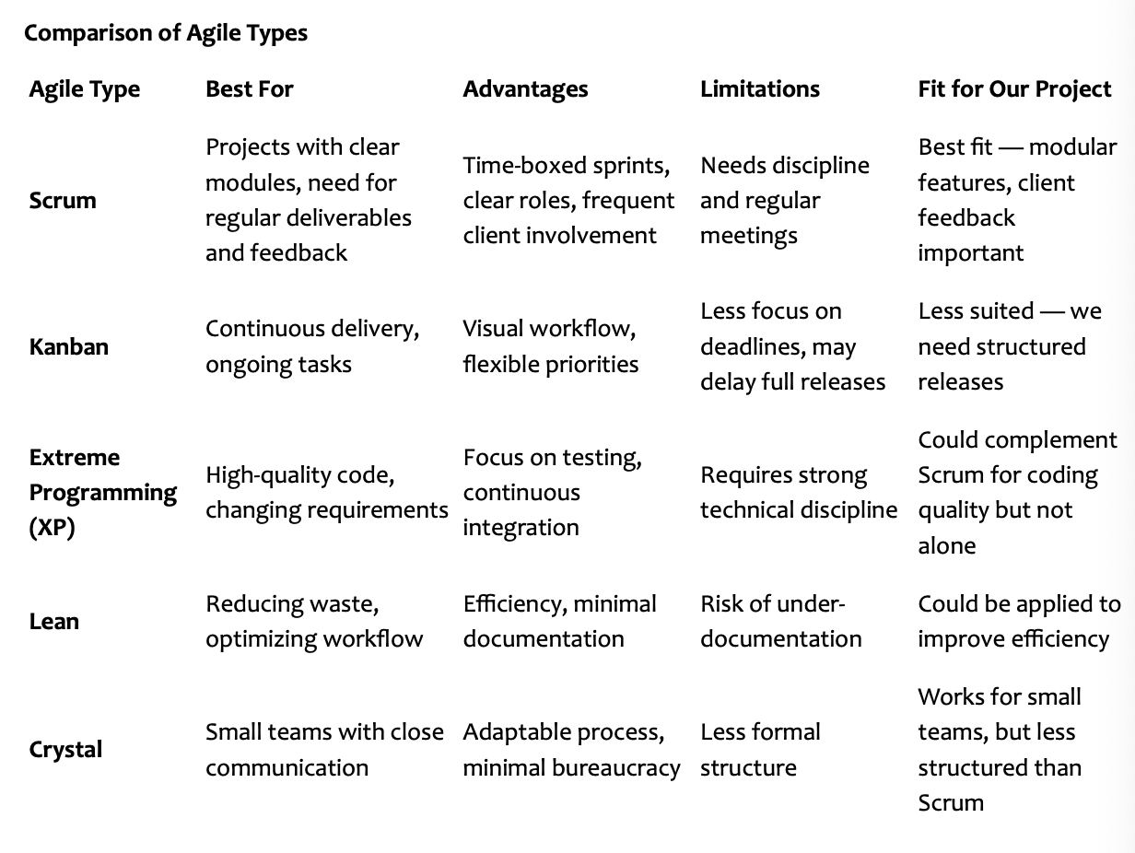

**Why Scrum Fits Our Project**

• Our project has clearly defined modules (Sales, Maintenance, Inventory, Reports, etc.) that can bedeveloped in short iterations (Sprints).

• Client feedback is essential — shop owners may request tweaks once they see the UI or printed reports.

• Roles can be clearly assigned:

1. Product Owner – the shop owner or their representative.
2. Scrum Master – we/project manager ensuring smooth process.
3. Development Team – programmers, testers, UI designers.

**Agile Scrum Plan for RPM Motorcycle Shop Management System**

**Sprint Length: 2 weeks**

**Estimated Total Duration: ~10–12 weeks**

**Sprint 1 – Core Setup**

• System architecture & database design.

• Basic UI framework (Arabic language support).

• User management module (login, role-based access).

**Sprint 2 – Sales & Product Management**

• Add/edit/delete motorcycles.

• View/filter motorcycles.

• Record sales & link to customer profiles.

• Generate & print invoices.

**Sprint 3 – Maintenance Management**

• Register maintenance requests.

• Schedule & assign technicians.

• Update service status.

• Spare parts usage logging

**Sprint 4 – Inventory Management**

• Spare parts stock tracking.

• Auto-update after usage.

• Low-stock alerts.

**Sprint 5 – Reporting & Final Touches**

• Sales, maintenance, profit, and performance reports.

• Printing functionalities.

• Usability improvements & bug fixes.

• Final testing & documentation.

**Special Agile Type Chosen:**

Agile Scrum – Iterative, time-boxed sprints delivering working features regularly, with feedback cycles after each sprint.